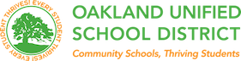

# **SOCIAL AND EMOTIONAL LEARNING**

Classroom Ideas for Using the Posters

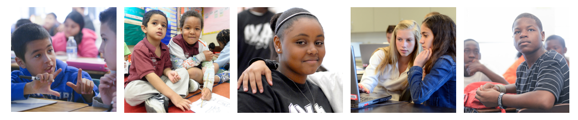

*Social and Emotional Learning (SEL), brought to scale, can and will play a significant role in shifting our culture of systemic inequality and violence toward a new ethos that values and prioritizes collaboration and partnership. We believe, based on strong social science evidence, that SEL has particular power to unlock a broad range of human capacities—intellectual and emotional—which prepare children to*

*co-create a kinder, more interconnected, and equitable future.*

### —NoVo Foundation, OUSD SEL Funders

## How to use the Social and Emotional Learning (SEL) Posters

These posters are a gift to your classroom to:

* ***Engage*** your students in understanding of the five basic SEL competencies
* ***Develop*** a common language around SEL
* ***Practice*** specific SEL skills
* ***Support*** regular self-assessment to continually deepen the conditions for effective learning

We hope the following list of ideas on how to use the posters will be helpful — and will also spark your own ideas — as you talk with your colleagues and students about SEL. Please share any additional strategies and activities you develop on our SEL website ([www.ousdsel.org](http://www.ousdsel.org)) so that educators across OUSD can grow together in our practices to support students in being able to show their whole selves, and their best selves, at school every day.

## Introducing the 5 Core SEL Competencies

As appropriate to your students, facilitate a brief discussion about each competency. Show how developing the first four skills leads to the fifth (responsible decision making) and/or introduce the idea of the five competencies and then share specifically about each one in up to five sessions.

* **Self-Awareness:** Share the definition of self-awareness from the poster and then ask each student to quietly think for a moment about something they have learned to do well. Have students pair/share or go around the room hearing every voice. Extend this activity by also asking what some of the things were that helped them to get more skilled in their area, and how they know they are good at it. Examples might include sports or music, built through repetition or effective coaching; sticking with something even when challenging; being able to cook or bake; bike-riding or playing a particular video game; or growth in an academic or school leadership role. This same activity can be repeated numerous times during the school year as students develop new skills and become more comfortable with naming and claiming them. Vary the sharing strategies for freshness: whole group (in order); whole group (random); partner shares (self-chosen); partner shares (random); personal reflection and writing.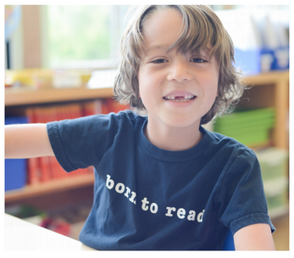
* **Self-Management:** Self-management is built on a foundation of self-awareness. After exploring the SEL definition of self-management, offer one scenario relevant to your student group where an individual is experiencing a potentially challenging situation that brings up strong feelings. (Examples: “I am anxious about an exam/basketball try-outs,” etc.) Have students think/pair/share or do a private quick write and pair/share in a series of brief, balanced-time conversations as you introduce a question like:
  + What are some specific strategies that people use to successfully manage their emotions, even when they are experiencing strong feelings?

Facilitating these group introductory lessons with generalized language, with the focus on “how might people feel” and “what might someone do,” lays the groundwork for deeper, more personal insights and interactions in the future.

* **Social Awareness:** Social Awareness is the ability to take the perspective of others and apply it to your interactions with them. It is also awareness of socially acceptable behavior. After sharing the definition of Social Awareness, have students explore concrete ways they can practice Social Awareness in class. For example: along with students, co-construct classroom agreements around how everyone can work effectively with every other student over time, and about what makes an engaging, enjoyable work environment. Use those agreements actively, having students read them aloud before lessons begin, and using them as a formative self-assessment tool after lessons.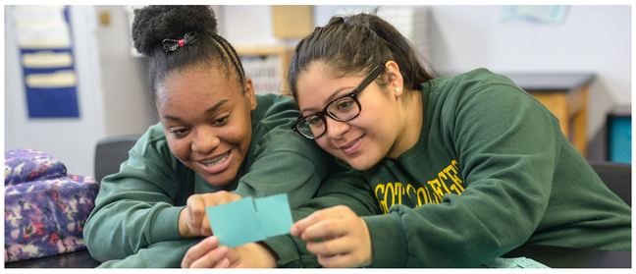
* **Relationship Skills:** After sharing the Relationship Skills poster definition, engage students in an activity that highlights effective communication skills by having them practice active listening or revisiting academic discussion procedures. These skills are used every day, so being transparent and intentional about building them will help students anchor the behaviors into new habits to draw on for success in your classroom and beyond. A question you might consider asking your students is:
  + What skills did I use so that my peers and I understood each other?
* **Responsible Decision Making**:  
   Add to your discussion of the definition on the poster the idea that Responsible Decision Making is a natural and desired outcome of becoming very skilled in each of the other four competencies. By attending to the previous four areas with direct skill-building lessons, practicing them through integration within academic lessons, and supporting students in regularly doing formative self-assessment (individually and related to their group work), students will build the skills necessary to be ready to thoughtfully make responsible decisions, even in times of exuberance and times of stress.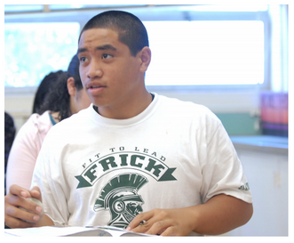

## Infusion & Integration

Integrating Social Emotional Learning (SEL) into classroom instruction and everyday interactions helps students set and achieve goals, manage emotions, feel and show empathy for others, and nurture positive relationships to establish a foundation for success in life. Choosing one SEL competency to focus on per lesson or assignment can also be a great way to start. For example, ~~a~~sking students to reflect on their understanding of a new concept they’ve been taught promotes self-awareness. Having students break down tasks into a smaller set of sequential goals supports development of self-management. Creating an opportunity in each class for students to reflect on and identify the SEL skills they’ve used in a particular activity or lesson helps to reinforce these vital competencies.

* After introducing the SEL Competency, co-construct classroom guidelines that refer to the competencies.
* Hold a competency as one of the focuses of an assignment — presentation, group discussion, study session — and ask students to choose a specific indicator they will pay particular attention to during the work session; they can then share that choice with a shoulder (accountability) partner, and self-assess with specific criteria at the end of the lesson. Groups may also indicate what aspect they mutually decided to work more intentionally on the next day, and say why.
* Class meetings or Restorative Justice Circles: ask which competency each student feels most prepared to use today.
* Utilize a competency poster’s questions daily as a gathering or closing activity, or incorporate a version of them within your content lesson.

