Oakland Unified School District

Pre-K-Adult SEL Standards

Oakland Unified School District’s Social and Emotional Learning (SEL) Standards were developed by a team of teachers, educators, central office administrators and staff, youth, and community members who worked together for a year.

Oakland Unified School District’s (OUSD) Pre-K-Adult SEL Standards are currently in use as: (1) an essential element in the district’s Instructional Rounds process for every school, (2) a guide for educators’ focus on Academic Discussion as the district transitions to the Common Core State Standards (CCSS), and (3) a tool for selecting materials and curriculum aligned to CCSS and Next Generation Science Standards (NGSS), which the California State Board of Education adopted in September 2013.

Purpose
In OUSD the Pre-K-Adult Social and Emotional Learning (SEL) Standards provide an SEL framework that is the foundation for academic content, instructional practices, leadership and learning for students and adults, from the classroom to the boardroom. This resource provides an example that other district leaders and staff can use to develop a common language, vocabulary, and definition for SEL in their own district and to define the skills students need for academic achievement and success in life. The SEL Standards are currently part of the conversation throughout OUSD, including instructional rounds debriefs, professional learning, development of school site plans and reviews, and other areas.

Similar to the medical rounds model, instructional rounds are a process for school improvement that brings groups of educators together to look at what is happening in their schools, develop a collaborative learning environment, and improve student learning. In OUSD instructional rounds is a districtwide strategy to advance the quality of teaching and learning for all students. It brings together principals, teachers, curriculum and SEL experts, and a broad range of central office staff to observe, gather evidence, and make recommendations for improvement. During the 2013-14 academic year every school site in the district hosted two instructional rounds, more than 800 classrooms were visited, and the learning experience of some 10,000 children was observed.

Content
- Oakland Unified School District’s Pre-K-Adult SEL Standards | One-page description of anchor standards, which are CASEL’s Five Competencies, with learning standards for each competency
- Student SEL Behaviors | Description of student behaviors and indicators for each of the five SEL competency areas

Using this Resource
District and school leaders and staff who are considering adopting or developing SEL standards can use OUSD’s Pre-K-Adult SEL Standards as a resource or guide in the development of their own district-level SEL standards.

Oakland Unified School District leaders and staff used Illinois and Washoe County SEL Standards, and State of California’s Pre-K Standards as sources. Any use or adaptation of this resource should cite Oakland Unified School District as a source.

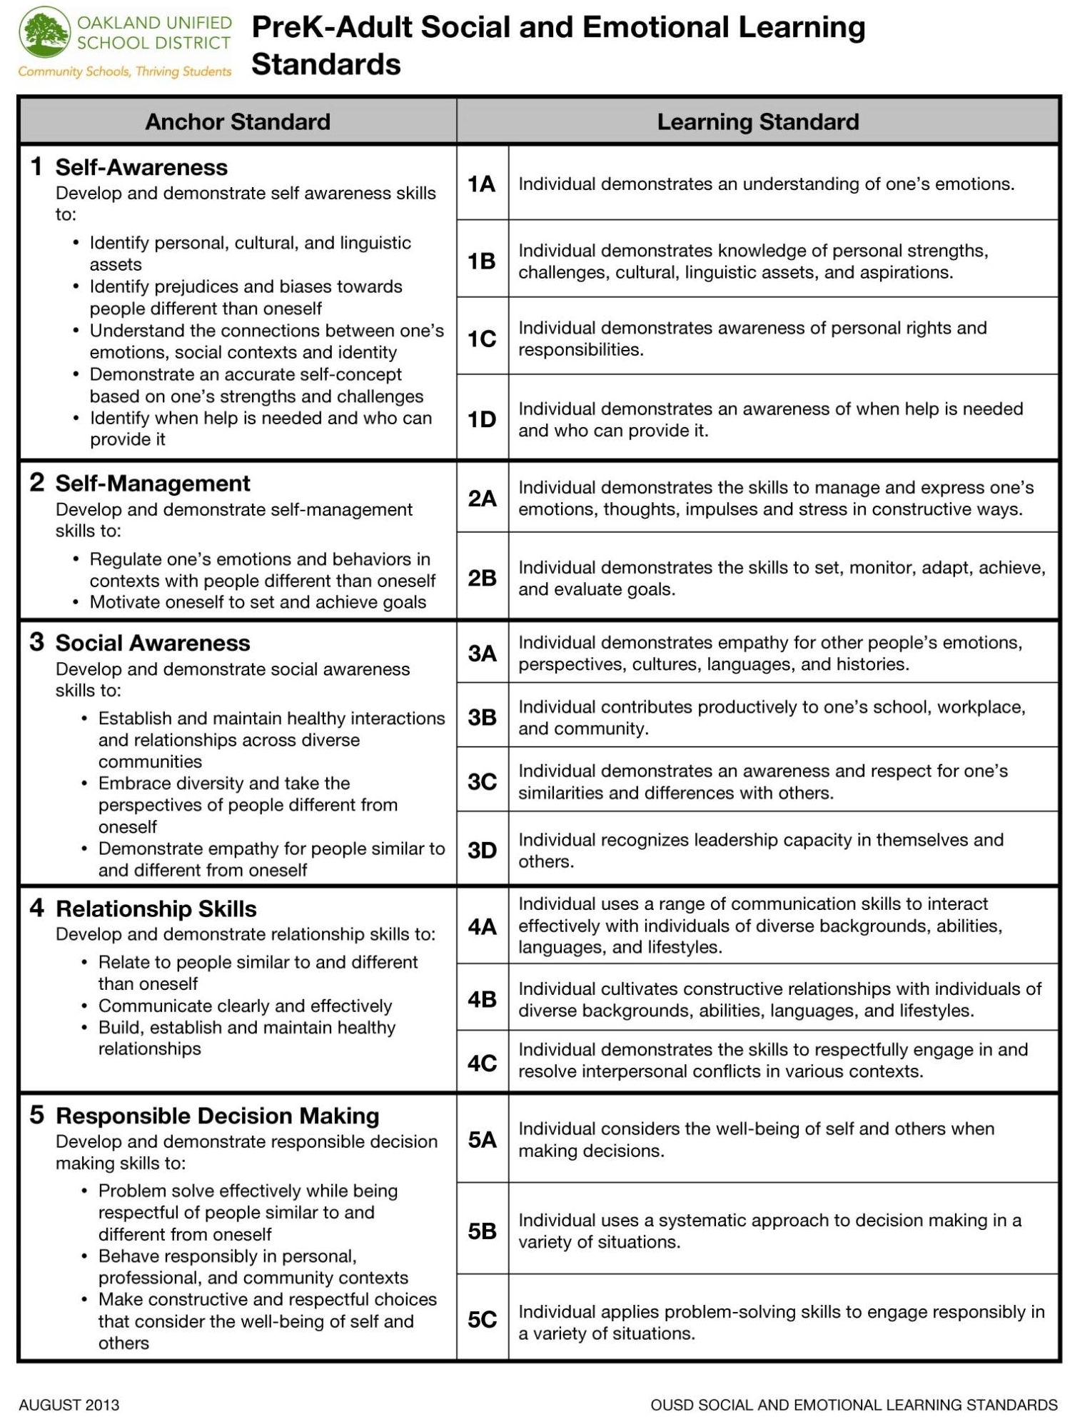
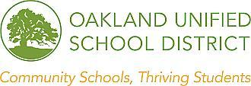
Academic Discussion SEL Competencies Analysis
Student Behavior and Language that Demonstrate SEL Competencies
SEL Competencies | Classroom Indicator Examples
Self-Awareness  Accurately assessing one’s feelings, interests, values, strengths, and challenges; maintaining a well-grounded sense of self-confidence | Students:  - Reflect on their progress as a learner  - Express what is easy or hard about the academic discussion¹ and why  - Ask for help when needed  - Identify their role and responsibilities during academic discussions
Self-Management  Regulating one’s emotions, thoughts, and behaviors to handle stress, control impulses, and persevere in overcoming obstacles; setting and monitoring progress toward personal and academic goals; expressing emotions appropriately | Students:  - Manage and express emotions, thoughts in a constructive way  - Stay engaged in discussion  - Use “I” messages in the social context of academic discussion
Social-Awareness  Being able to take the perspective of and empathize with others; recognizing and appreciating individual and group similarities and differences; recognizing and using family, school, and community resources | Students:  - Listen attentively to other’s ideas  - Respectfully paraphrase other’s ideas  - Engage collaboratively with people different from oneself  - Able to take the perspective of people different from oneself  - Add on to and build off of other’s ideas
Relationship Skills  Establishing and maintaining healthy and rewarding relationships based on cooperation; resisting inappropriate social pressure; preventing, managing, and resolving interpersonal conflict; seeking help when needed | Students:  - Communicate clearly and effectively with people different from oneself  - Engage in constructive argument  - Give and receive constructive feedback  - Listen, encourage, acknowledge, compromise, work towards consensus  - Express value of collaboration  - Ask questions based on careful listening
Responsible Decision-Making  Making decisions based on consideration of ethical standards, safety concerns, appropriate social norms, respect for others, and likely consequences of various actions; applying decision-making skills to academic and social situations; contributing to the well-being of one’s school and community | Students:  - Follow norms established for the discussion  - Actively participate in group decision-making process  - Generate alternative ideas and solutions  - Demonstrate the “good of the group”  - Ask “why” and “what if” questions

¹The District defines academic discussion as quality academic discussion as purposeful, sustained conversations about content. It requires students to work together to co-construct knowledge and negotiate meaning in order to attain high levels of thinking and deep understanding about a topic, and is characterized by high student engagement and participation, as students discuss relevant topics that allow for multiple and diverse perspectives.

OUSD Office of Social Emotional Learning and Leadership Development ver.1/Oct. 2013

