Highlights from the Baseline SEL Staff Implementation Survey at **** School

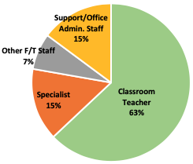
In the fall of 2019, 27 staff members at **** School completed the CASEL staff implementation survey to collect baseline data on implementation of social and emotional learning (SEL). This preview includes high-level takeaways that illustrate our progress thus far.
It is important to note that we are at an exciting starting point in our SEL journey! All data should be viewed as our starting point to inform our work going forward; it is not evaluative in nature.
As we move into the new semester, your SEL specialist will assist you in using these results to guide goal setting, action planning, and professional learning.
Key Themes
- Based on the baseline data collected, the staff at **** have a strong understanding of and commitment to SEL.
  - Nearly all staff (96% and 100%) reported a commitment to promoting social and emotional competence in their students, and a belief that SEL is related to academic success.
  - 96% felt encouraged to reflect on and continuously improve their own social and emotional competence.
- Continue to build a schoolwide SEL foundation and work to involve all staff members in these processes.
  - 90% of SEL team members understand their responsibility in ensuring meaningful integration of SEL.
  - 89% of staff agreed that they were involved in developing the vision for schoolwide SEL at ****.
- The adult-facing professional learning (PL) work has explored the SEL competencies through an equity lens.
  - 96% of staff regularly work to understand the perspective of diverse peers and students.
  - 93% of staff reported attending PL sessions that cultivate their own social emotional competence.
  - Higher perceptions of staff members modeling positive SEL was related to higher perceptions of a school that is a good place to work and learn, as well as more of supportive of SEL.

Potential Action Step:

- Incorporating stakeholders’ voices promotes equitable student outcomes. SEL serves as a lever for equity, as higher perceptions of a supportive of SEL culture were linked with higher perceptions that students of all races are treated equally and fairly.
  - 85% of staff believe the school’s disciplinary practices are applied equitably with all students.
  - Overwhelmingly, staff agree that each classroom displays, communicates, and reinforces their classroom shared agreements (94%) at ****.

Potential Action Step:

- Empowering all staff to collect and use data can be a powerful tool for continuous improvement.
  - 44% of SEL team members believe their team has identified long-term goals as part of their future SEL plan.

Potential Action Step:

The chart below highlights a few key items related to the themes described above:
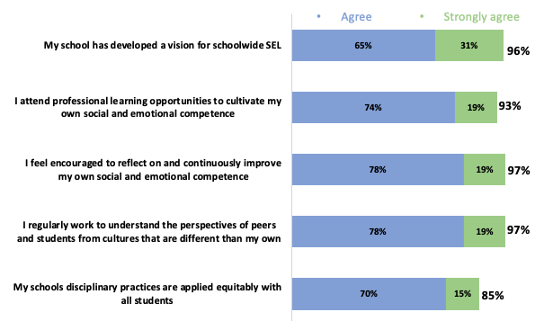
Using our Data to Inform Action Planning:

